ABOUT ME
My First Initial:
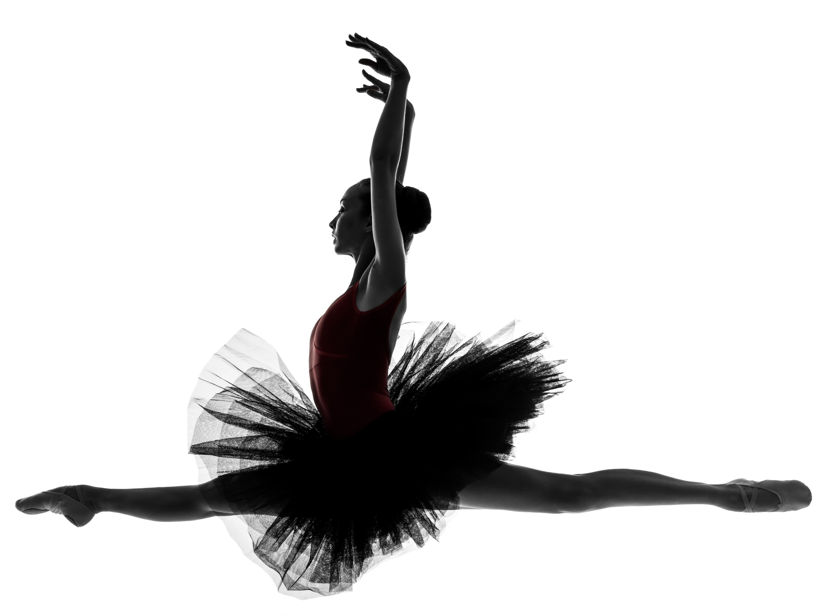
My age:
School I attend:
Favorite Thing to do when I’m not Dancing:
Favorite Book or TV Show or both:
Favorite Treat:
Favorite Song:
Circle one:
Would you rather tap or hip hop?
Would you rather leap or turn?

